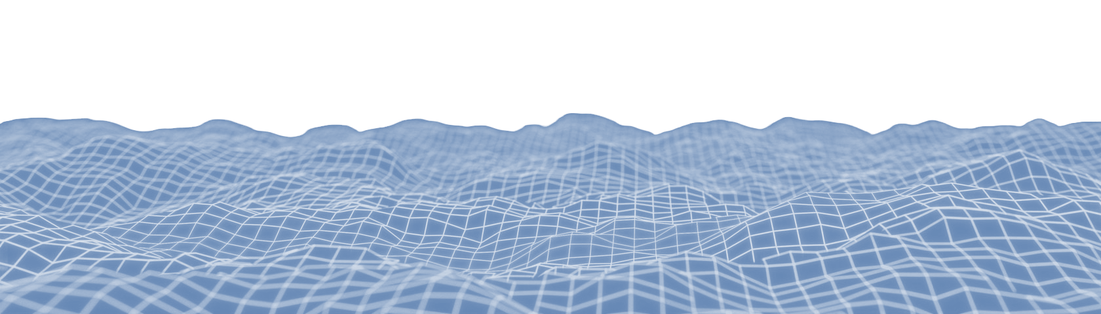
Dominic Barbuto

518-415-8774
dominicabarbuto@gmail.com
LinkedIn
dominicbarbuto.com
Gameplay Software Engineer
OBJECTIVE
As a versatile game developer, I am driven to blend my programming and artistic knowledge to craft immersive gameplay systems, delivering fun and engaging gaming experiences that resonate with players.

SKILLS
- C/C++ (10+ years), C# (6+ years), Python (2+ years)
- Unreal Engine 3-5.4 (15+ years)
- Unreal Engine Online Subsystem (1 year)
- Unreal Engine 5 Niagara (4+ years)
- Unity (6+ years)
- Visual Studio (10+ years),
- DirectX 11/12, HLSL (3+ years), RenderDoc
- Git (6+ years) – Bitbucket, GitHub via command line and GUI (GitHub Desktop, SourceTree)
- Perforce (2+ years)
- JIRA, Confluence, Trello (4+ years)
- Blender, Photoshop, Substance Painter (10+ years)

- Game engine design fundamentals with advanced data structures and binary/hexadecimal operations.
- Proficient in 2D/3D rendering, physics, collision algorithms, and custom C++ gameplay logic systems.
- Strong 3D math skills (linear algebra, calculus) and experienced in UE5 C++ and Blueprint conversions.
- Passionate about Unreal Engine Animation Blueprints, character design, and the 3 C’s (Character, Controls, Camera).
- Gaining experience in multiplayer programming with UE’s and Steam’s Online Subsystems.
- Extensive 3D modeling, texturing, rigging, and animation knowledge.
- Excellent communication, collaboration, leadership, and project management skills.
TECHNOLOGY

EDUCATION
CERTIFICATIONS
Full Sail University | Winter Park, FL | 11/2023
Unity
- Certified Associate: Programmer
- Certified Associate: Game Developer
- Certified User: Programmer
- Bachelor of Science | Game Development
- Course Director Awards: Programming II, Project & Portfolio III
Hudson Valley Community College | Troy, NY | 12/2021
- Associate of Science | Computer Information Systems
- President’s List & Dean’s List Awards

WORK EXPERIENCE

Creative Director | Domension Studios LLC (06/2024 – Present)
- Company owner and team builder. Manages budgeting, contracts, and other studio operations as an LLC.
- Leading production and development of our upcoming flagship multiplayer game title.
- Team leader who trains and guides teams to achieve goals and realize the project's creative vision.
- Lead developer, mainly network programming in C++ Unreal Engine 5.

Unreal Engine 5 C++ Game Programmer | Cornered Rat Software | Internship (02/2024 – 08/2024)
- Tasked with transferring proprietary technology from WWII Online 1.0 to Unreal Engine 5 for WWII Online 2.0.
- Led the programmatic recreation of terrain and object data from WWII 1.0 into UE5 using a custom event system based on UE’s World Partition.
- Achieved efficient rendering of entire towns with a custom lazy loader and GPU instancing.
- Collaborated with the lead developer and team on tasks and issue resolution via Slack and managed workflow in JIRA/Confluence/Bitbucket.

PERSONAL PROJECT EXPERIENCE
Systems/Gameplay/Graphics Programmer | Puzzle Paradox | Full Sail Capstone Project | First-Person Puzzle Platformer | 11/2023 (4 Months)
Built with Custom C++ Engine | Team Size of 1
A unique first-person puzzle platformer. Evade hazardous obstacles while solving puzzles in a dark, ancient tomb setting.

Tasked with designing and building core systems, custom asset pipeline, gameplay systems, and rendering.
Core System and Gameplay Design
- Designed and developed core systems, including a 2D/3D renderer, audio, input, event dispatching, and state management.
- Built gameplay systems using a Fast Lightweight Entity Component System (FLECS) and integrated open-source APIs.
Custom Asset Pipeline
- Created an asset pipeline for exporting level data from Blender to the engine with efficient I/O and data handling.
Gameplay Systems
- Developed ECS-based game logic, custom physics, collision detection, and matrix transformations.
- Integrated 2D/3D positional audio and built view-to-world space raycasting similar to Unity’s screen-to-world.
DirectX 11 Renderer
- Designed buffer and state management for vertex, index, and instance buffers, ensuring modularity and clean memory management.
- Implemented lighting models (Diffuse, Ambient, Specular) and custom lighting exported from Blender with real-time adjustments.

Systems/Gameplay Programmer | Infinity Field | Full Sail Mid-Capstone | Sci-Fi Shooter | 01/2023 (2 Months)
Built with Unity | Team Size of 6
A fun, first-person linear sci-fi shooter filled with a wide variety of enemies, weapons, and level aesthetics.

Tasked with handling core gameplay, visuals, animation, and overall player experience. Very rapid work pace.
Gameplay & AI
- Designed 3 unique boss fight scenarios using a state machine design pattern.
- Developed interactable environments (doors, elevators, lootable props) and hazardous areas.
- Implemented distinct actions and behaviors for weapons and player types, along with an enemy wave system and squad communication for dynamic AI.
Art & UI
- Textured multiple weapons and enemies with variations.
- Designed all UI, including menus, HUD, main menu cutscenes, and audio integration.
Animation
- Created custom rigs and animations for unique enemies with IK pinning.
- Designed weapon animations (switch, shoot, reload) and adapted third-person rigs for a first-person view.
- Built complex animation controllers with smooth transitions across blend trees.

